震災被害の自然標本修復 ２日から国立科学博物館で展示

Natural Specimens, Damaged in Tsunami, Now Restored

Exhibit Starting on the 2nd at National Botanical Museum
東日本大震災で大きな被害をうけた東北地方の博物館から、化石や植物標本を探し出し、修復する活動が広がっている。７月２日から東京・上野の国立科 学博物館で、企画展に合わせて、救出した自然史標本を集めた支援展示も始まる。活動を知ってもらい、被災館の支援につなげる狙いだ。
[Scientists] have recently begun efforts to search out and restore fossils and plant specimens from the Tohoku museum that was damaged in the Sendai earthquake. Also, in the National Botanical Museum in Ueno, Tokyo, an exhibit of plant specimens rescued from the Tohoku museum has begun. The goal is to increase awareness of the restoration activity, and to promote support for the damaged museum.
大津波で、岩手県では、陸前高田市立博物館で収蔵品１５万点が水没、山田町の鯨と海の科学館では、８万点の海藻標本の大半が流出。生物標本だけで被害は１３万点と見られる。
In Rikuzentakata’s Hachi-Museum (??), 150,000 of the collected items were submerged by the tsunami. In Yamatacho’s Whale and Sea Museum, 80,000 items, including many seaweed specimens, were washed away. It appears that 130,000 live specimens were also damaged.
宮城県南三陸町で貴重な魚竜化石を展示していた魚竜館が津波にのまれ、宮城県や福島県でも被害が出ている。
In Minamisanriku-cho, Miyagi-ken, a valuable ichthyosaur fossil on display in the dinosaur museum was damaged by the tsunami; other damage was suffered in Miyagi-ken and Fukushima-ken (???)

標本救出は４月ごろから始まった。絵画や工芸品のような文化財保護法の後ろ盾がない自然史標本では、被災地周辺や全国の学芸員や研究者らの多くが手弁当で現地に入り、土砂や重油にまみれた標本を見つけ出してきた。

The specimen rescue operations began in April. Unlike painting and handicrafts, which are protected by the Law for the Protection of Cultural Properties, there is no law guarding biological specimens. For that reason, museum curators and scientists from the surrounding area and all over the country, have come to the affected area and are working without pay to find the specimens, which are often buried in mud, sand, and oil.
救出された標本は、各地の博物館に送られ、海水をかぶった標本の塩抜きや、昆虫標本の修復などが続けられている。

The rescued specimens are sent to other museums, where operations such as the removal of salt from specimens that were immersed in seawater, the reconstruction of insect exoskeletons are continuing.
２日からの復興支援展示では、被災地で救出され、国立科学博物館に運ばれた標本のうち４３点を展示する。「恐竜博２０１１」（朝日新聞社など主催）の会場内で開催。１０月２日まで。（竹石涼子）
At the Recovery Support Exhibit starting on the 2nd, 43 specimens that were rescued from the disaster area and sent to the National Botanical Garden will be on display.
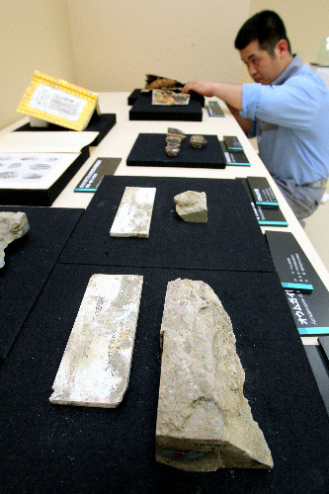
無断転載・複製を禁じます。

津波で壊れた岩手県陸前高田市立博物館から探し出した化石など＝

国立科学博物館、林敏行撮影
記事「震災被害の自然標本修復 ２日から国立科学博物館で展示」より

Fossils from the museum of Rikuzentakata, Iwate were damaged and lost in the tsunami, but later rediscovered.
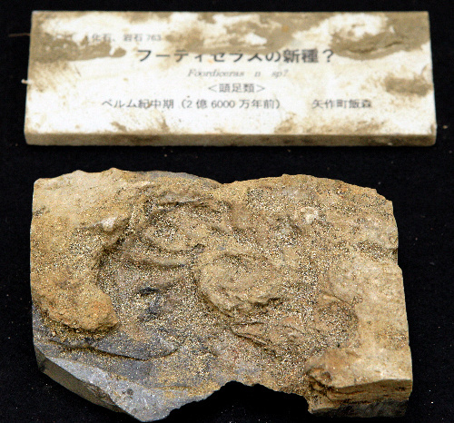
無断転載・複製を禁じます。

津波で壊れた岩手県陸前高田市立博物館から見つかったオウムガイ類の化石＝東京都台東区上野公園の国立科学博物館、

A nautilus fossil from the public museum in Rikuzentakata, Iwate, damaged and lost in the tsunami, but later found. Now at the National Botanical Museum in Ueno Park, Taito-ku, Tokyo.

